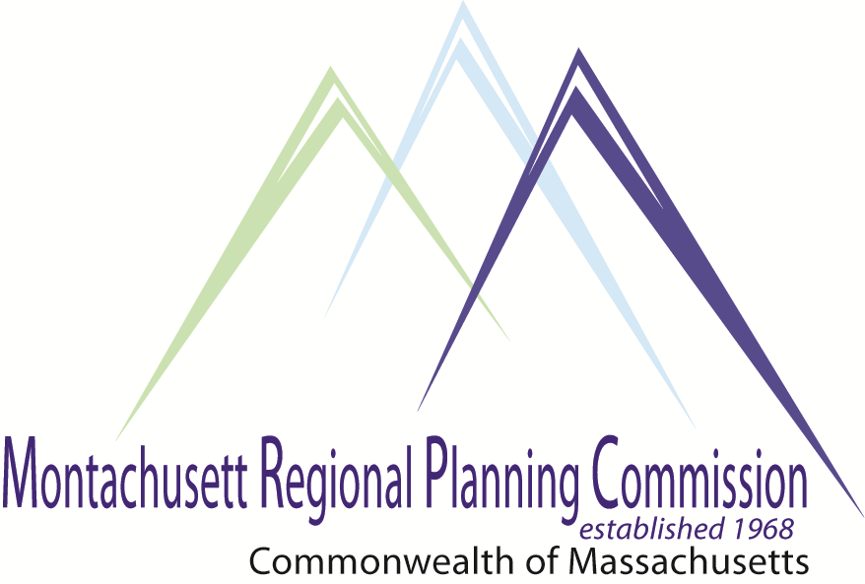 Posted 6.24.2014 at 2:45pm by JAD

**5:00 PM**  **Light Dinner and Networking**

**5:15 PM Introductions and Welcome:** *Victor Koivumaki, Chairman, MRPC*

**5:20 PM MassDevelopment Programs to Help Finance Infrastructure Development.**

*Kim Mooers, MassDevelopment*

5:45 PM USDA Programs to Help Finance Infrastructure Development.

*Leonard Schuzdak, USDA*

*(Holden Area Office)*

6:10 PM Route 2 Corridor Grant Application.

*Glenn Eaton, MRPC*

*Executive Director*

6:20 PM Administrative Matters

6:30 PM Adjournment

**C: City and Town Clerks: Please post this notice pursuant to the Open Meeting Law**

**Please RSVP by June 24th, 2014 via: jhume@mrpc.org**

**Come Join Us to hear about Infrastructure and Public Improvement programs. Kim Mooers from MassDevelopment and Lyndon Nichols from the USDA will be discussing the programs available to help finance infrastructure projects.**

**June 26, 2014 at 5pm**

**MRPC Conference Room**

**1427R Water Street Fitchburg, Massachusetts 01420**

# *Comprehensive Economic Development Strategy (CEDS) Meeting*

## AGENDA